

|  |
| --- |
| **Date :** 10 Mar 2021 |
| **Version :** 1.0 |
| **Author :** Team Certiorem |

#### Version history

|  |  |  |  |  |
| --- | --- | --- | --- | --- |
| **Version** | **Date** | **Author(s)** | **Changes** | **State** |
| 1.0 | 10 Mar 2021 | Tsanko Nedelchev, Menderes Sacli | First draft | In progress |
| 1.1 | 23 Mar 2021 | Tsanko Nedelchev | Added some more research questions |  |
|  |  |  |  |  |

**Distribution**

|  |  |  |
| --- | --- | --- |
| **Version** | **Date** | **Receivers** |
|  |  |  |
|  |  |  |

Contents

Version history 1

Project assignment **2**

Context 3

Goal of the project 3

Scope and preconditions 3

Strategy 3

Research questions 4

End products 4

Project organisation **4**

Stakeholders and team members 5

Communication 5

Activities and time plan **5**

Phases of the project 6

Time plan 6

Testing strategy and configuration management **6**

Testing strategy 7

Test environment and required resources 7

Configuration management 8

Finances and risk **8**

Project budget 9

Risk and mitigation 9

# Project assignment

## Context

Sioux Technologies is a global technology partner that supports or acts as the research and development department for high tech companies. They hired our team – Certiorem to develop an application that helps with managing the parking lot and parking for visitors as a whole at the Sioux building in Eindhoven.

## Goal of the project

The goal of this project is to improve the experience and optimize the process of parking for visitors to the Sioux building in Eindhoven.

Currently there are 2 parking lots at the location – one of the parking lots is located at the building itself, and the other, which is the larger of the two, is located in close proximity. Nonetheless, there are no instructions to guide the visitor to the second available parking lot in case the main one is full.

That is why our team is entrusted with developing a system that will guide and inform each visitor of the availability of parking spaces for the main parking lot.

This will be achieved by scanning the visitor’s license plate by a camera at the entrance and connecting it with their phone number.

Consequently, the system will check if there are any parking spaces available in the main parking lot. In that case the visitor will be informed via a mobile text message that they can park there.

Furthermore, in the case that there aren’t any parking spaces available, the visitor will be guided to the location of the bigger parking lot.

This project adds value to the company by providing an easier and more efficient parking for the visitors which will improve their experience as a whole.

## Scope and preconditions

|  |  |
| --- | --- |
| **Inside scope:** | **Outside scope:** |
| 1. We will develop a software that uses a camera’s output to read the license plates of the vehicles that enter and exit the parking lot. | 1. We will not provide any camera support or firmware updates. Our application will simply use the footage from the camera. |
| 1. We will create an application that saves a visitor’s information. The options to edit and remove entries will be available as well. | 1. We will not create an application for the visitor to input their information as that will be handled through MS Outlook |
| 1. We will create a database that supports the back end of the application where the visitor’s information can be saved and used later. |  |
| 1. Our software will be able to send a text message to a mobile phone number to notify the visitor of their parking options upon arrival. |  |

## Strategy

We will work according to the scrum agile methodology and we are going to divide the whole project into 5 sprints - each lasting 3 weeks. At the end of each sprint we will submit the deliverables to the product owner and we will decide what the deliverables will be for the following sprint. Scrum is best for this type of project as we have rather limited time to complete all tasks. The fact that we will deliver a different part of the software each sprint means that we can maximize the amount of feedback that we receive which in turn will help us develop software that is 100% in line with what is needed.

## Research questions

|  |  |
| --- | --- |
| Research Question | Approach/Methodology |
| 1. What license plate recognition software is available and how does it work? | Library: Available product analysis  Workshop: Prototyping |
| 1. How can a web application send a text message to a phone number. | Library: Best good and bad practices |
| 1. Which is the best front end javascript framework for this project. | Library:”Community research, SWOT analysis. |

## End products

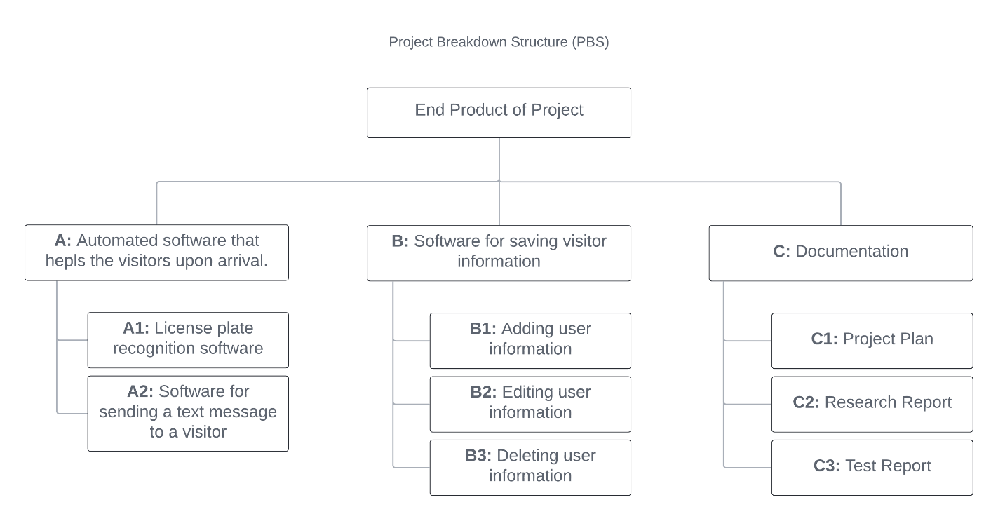

# Project organisation

## Stakeholders and team members

|  |  |  |
| --- | --- | --- |
| **Name** | **Role and functions** | **Availability** |
| Jan Willem Van Silfhout | Product Owner | Once per sprint |
| Menderes Sacli | Developer | 20 hours a week |
| David La Gordt Dillie | Developer | 20 hours a week |
| Chao Shi | Developer | 20 hours a week |
| Florin Deleanu | Developer | 20 hours a week |
| Tsanko Nedelchev | Developer | 20 hours a week |
| Batshal Bhattarai | Scrum Master | 20 hours a week |

## Communication

Team Certiorem uses Discord, Whatsapp, Outlook and Microsoft Teams to communicate with each other. On whatsapp and microsoft teams this is made by messages. In discord it is made by calls and messages.

We use Microsoft Teams and Outlook to communicate with our mentors and the product owner.

Whatsapp is used for when the team members are not on their computers.

Discord is where the team shares their documents, makes meetings in the form of voice calls and works on the project together.

# Activities and time plan

## Phases of the project

**Problem Analysis:**

Due to us following the agile methodology we split the project into sprints. A sprint takes 3 weeks to be completed.

Before we start a sprint we plan on what we want to accomplish in the upcoming sprint. After we decide and assign tasks to the team members we work on the tasks.

**Evaluation / Reflection:**

Due to the flexibility of the agile methodology if a task wasn’t able to be accomplished in that sprint we can discuss with the team if we still want it, if the answer is yes we can re assign it for the next sprint, if not we can scrap the task.

**Wrap up:**

Before submitting the sprint the team should review each team member’s work.

## Time plan

|  |  |  |
| --- | --- | --- |
| **Sprint** | **Start date** | **Finish date** |
| Sprint 1 | 04/03/2021 | 26/03/2021 |
| Sprint 2 | 29/03/2021 | 16/04/2021 |
| Sprint 3 | 19/04/2021 | 07/05/2021 |
| Sprint 4 | 10/05/2021 | 28/05/2021 |
| Sprint 5 | 31/05/2021 | 18/06/2021 |

# Testing strategy and configuration management

## Testing strategy

**Unit testing:**

We are going to be using Unit testing which will be automated. The best strategy would be to unit test the parts of the code that might get changed as the project progresses so that we can keep track on what effect our changes have on our application.

**Component testing:**

After the code has passed the unit testing we are going to proceed with the component testing which will be done for all components and It will be done manually and everytime after a new feature is completed and implemented.

## Test environment and required resources

We will make use of GitLab and a CI/CD pipeline that will provide automatic testing after the unit tests have been created and the component testing has been passed.

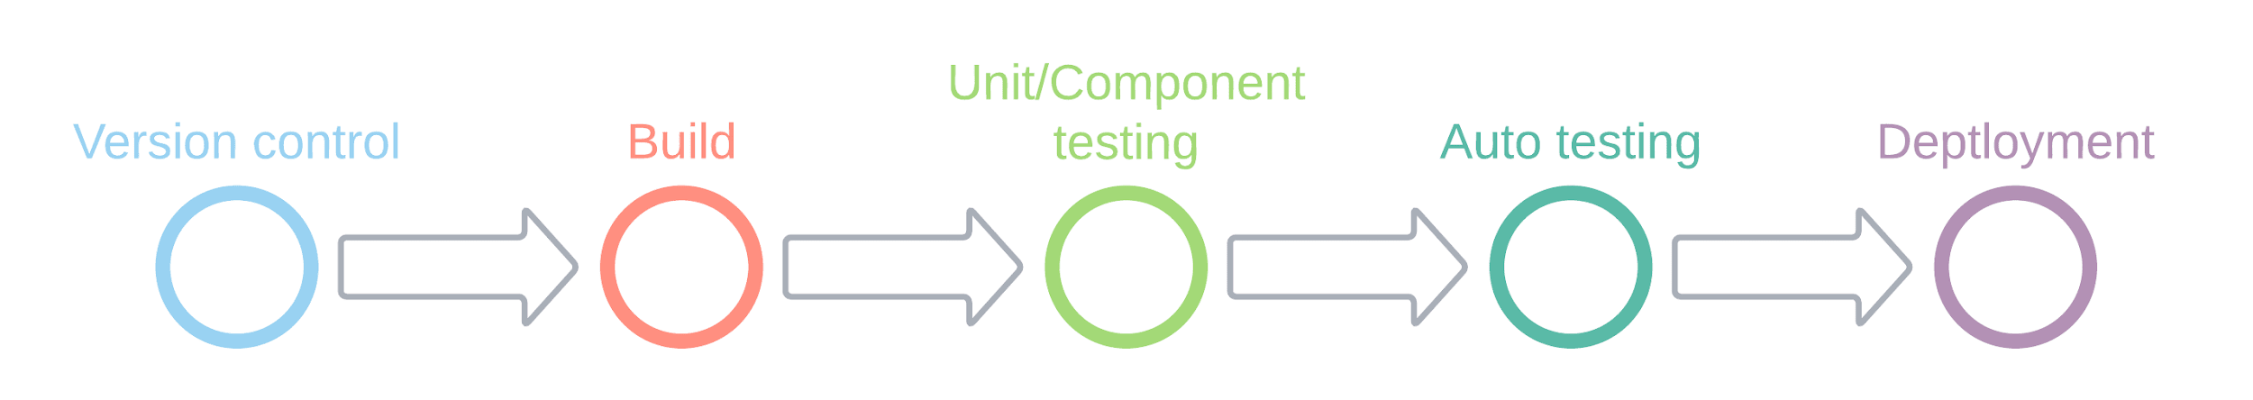

## Configuration management

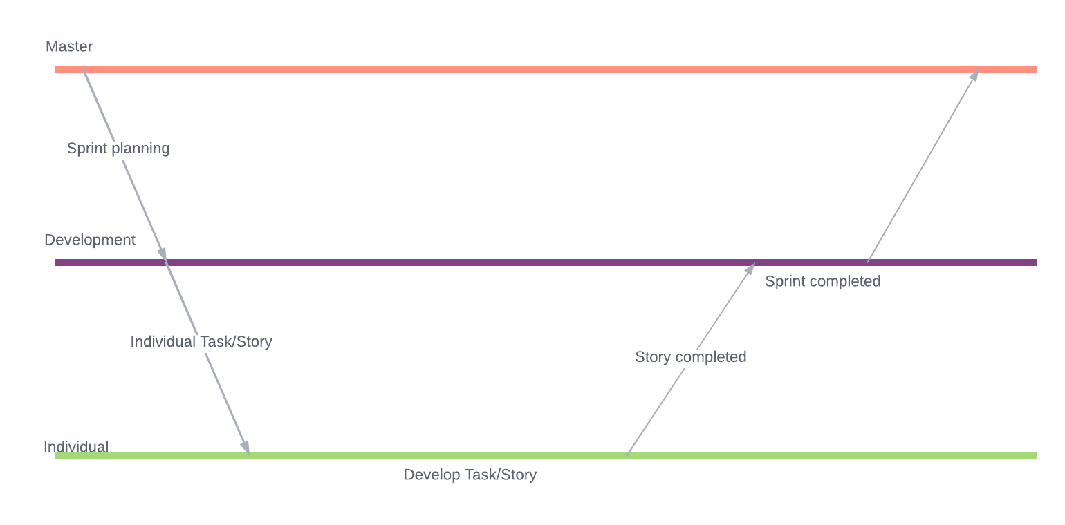

We will be incorporating the use of a Development branch which will serve as the “current-sprint-changes” branch. Further than that we all have Individual branches that we use to work on our assigned tasks/stories. Once a task or a story is finished by a developer in their own Individual branch it is then merged with the Development branch and is waiting for the release in the Master branch at the end of the sprint.

# Finances and risk

## Project budget

Team Certiorem’s project does not have a budget. Therefore no financial risk.

## Risk and mitigation

|  |  |  |
| --- | --- | --- |
| **Risk** | **Prevention activities** | **Mitigation activities** |
| 1. Member getting sick | Wear a mask, stay 1.5m away from other people, avoid crowded places. | Distributing the tasks that are left unattended onto the members present and reorganizing the workforce. |
| 1. Getting behind schedule | Planning – Make use of charts and communication applications and focus on what’s left to be done and how to do it in time. Having regular standup meetings | Reiterate on what is missing and create a better schedule that will fit the new time left. |
| 1. Low team motivation | Make notice in every meeting of what was achieved and try to show the team members they are valued. | Team Building - motivate the members of the team and visualize the goal. |